DSA THEORY (3B) 2020.

ASSIGNMENT 01

ALGORITHM AND CODE OUTPUTS.

MUHAMMAD DANISH | CS182019 | 3B . **COURSE INSTRUCTOR**: Miss Aneela Nargis

Program is checking the time complexity of the code present in the input.txt file. The algorithm of checking and code outputs are below.

**Condition:** Code should be present in file.

**Output:** Calculated run time complexity.

**Program Algorithm:**

Load string forWord= “for” ;

Load int forCounter;

Load string modWord = “%”;

Load int modCounter;

Load File = “input.txt”;

Open File = “input.txt”;

Read file in string.Format;

While(File >> fileWord)

{ If ( fileWord == forWord )

forCounter++;

if ( fileWord == modWord )

modCounter++;

} Close File = ”input.txt”;

if(forCounter > 0) {

if(modCounter > 0)

cout<<" The algorithm have ARTC of O(log n)";

else **// else linear complexity with loops**

cout<<"\nThe algorithm have ARTC of O(n)^"<<forCounter;

}

else **// else there will be a one line statement (intialization , printing etc..)**

{ cout << "\nThe algorithm have constant complexity of O(1)."; }

The above algorithm will open a file in string format and search for the specified keywords. Than the counter is incremented with each found. If the code is with simple linear loops it means it will print 0(n)^loopCount, if it is with loops and the size is getting lesser with input than it is 0(log n) print. And at last if nothing is true than constant complexity is calculated and printed.

**Code Outputs Screenshots:**

**Constant Complexity:**

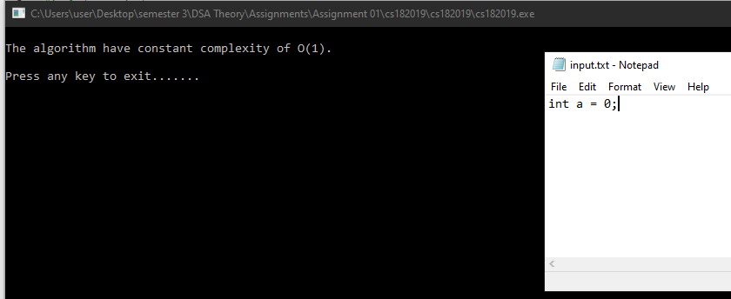

## **O(n) complexity:**

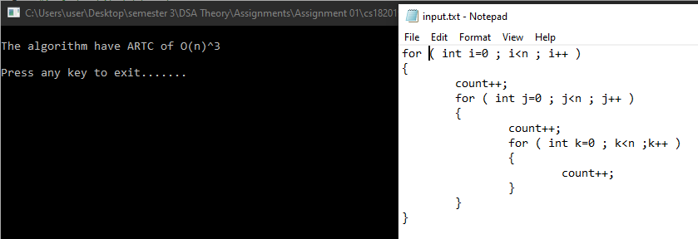

## **O(log n) complexity:**

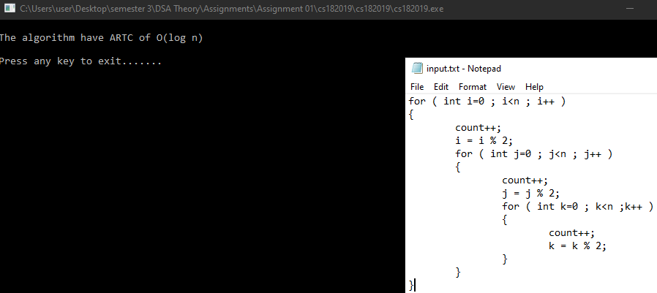

X --------------------------------------------------------------------------------------------------------------------------------------X

MUHAMMAD DANISH | CS182019 | 3B . **COURSE INSTRUCTOR**: Miss Aneela Nargis